
Touchstones Project
Netcards

Pluralism Netcards with Text

Authoritarianism HRJ
Beauty HRJ
Board Game HRJ
Celebration HRJ

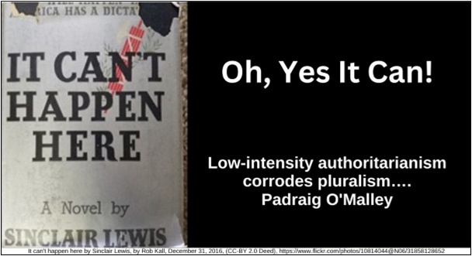

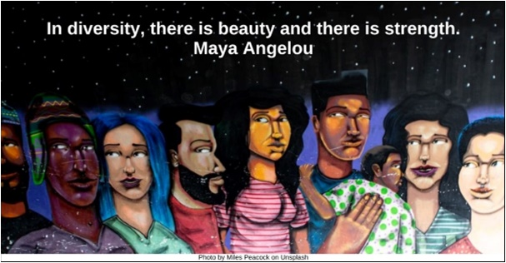

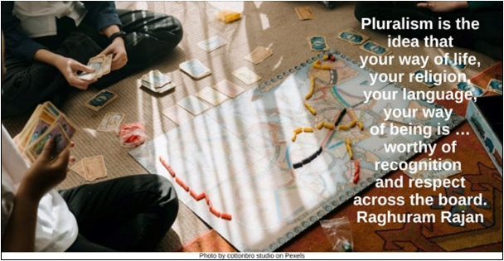

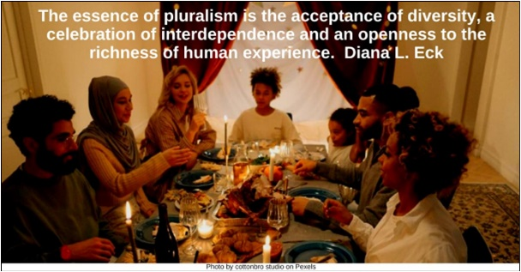

Chorus HRJ
Civilization HRJ
Complexity HRJ
Demographics HRJ

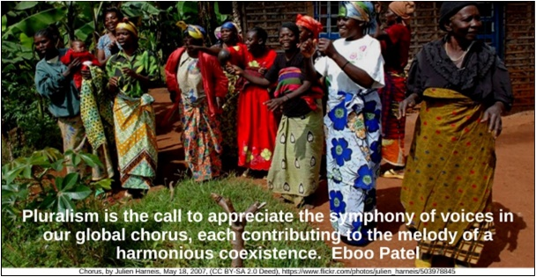

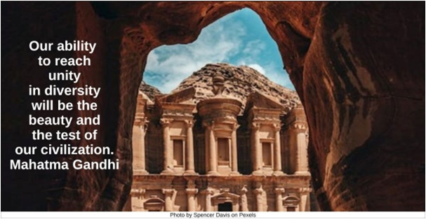

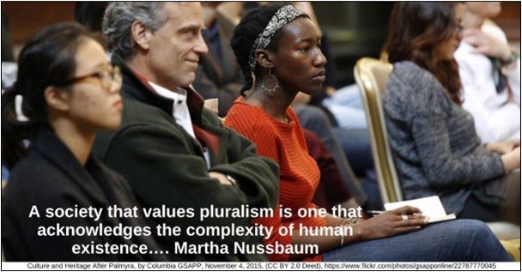

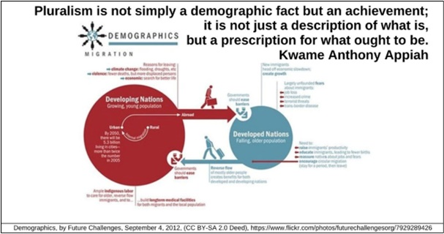

Dining Table HRJ
Diversity of Approaches HRJ
Education HRJ
Empathy HRJ

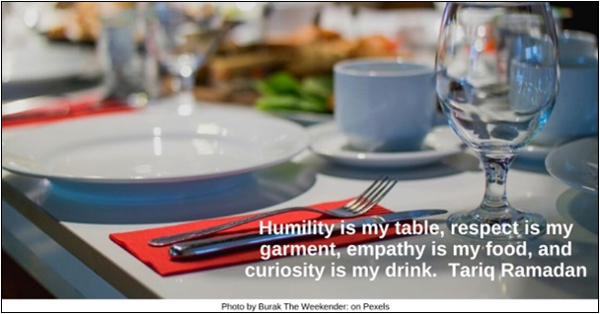

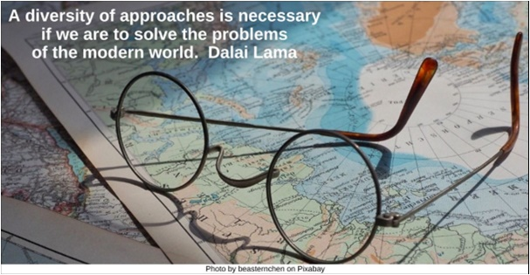

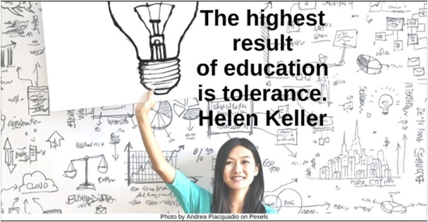

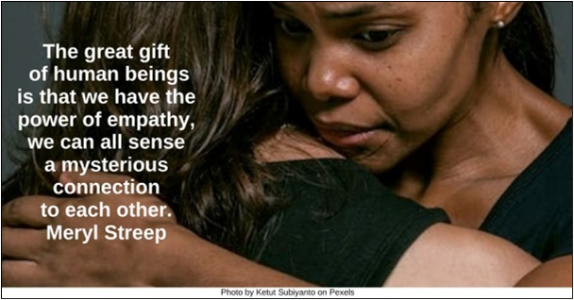

Encounter HRJ
Flower Garden HRJ
Gift HRJ
Movement HRJ

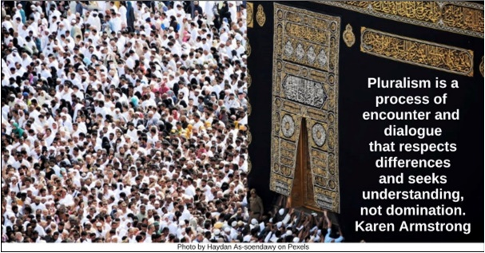

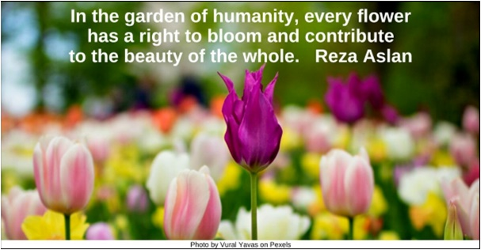

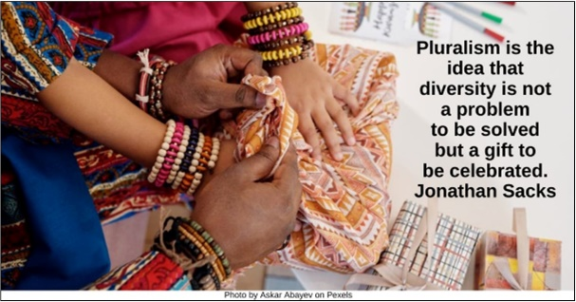

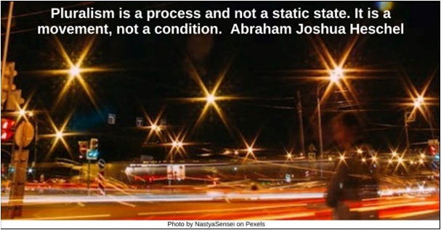

Niagara Falls HRJ
Not Diversity Alone HRJ
Other People HRJ
Radiant HRJ



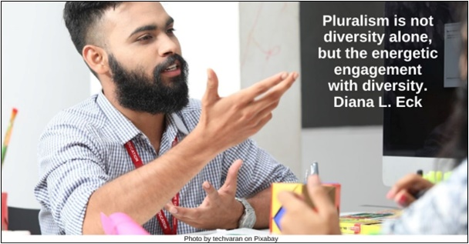

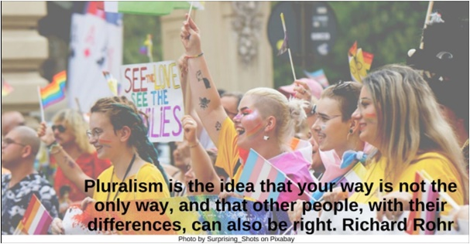

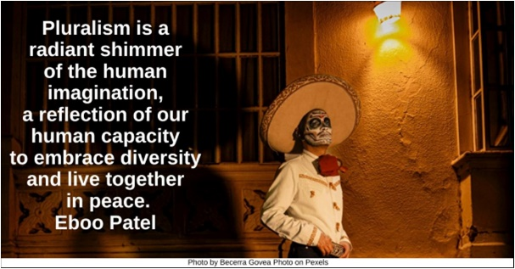

Respect HRJ
Shoes HRJ
Speak Up HRJ
Strength HRJ

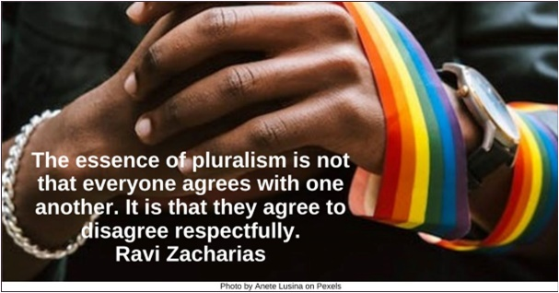

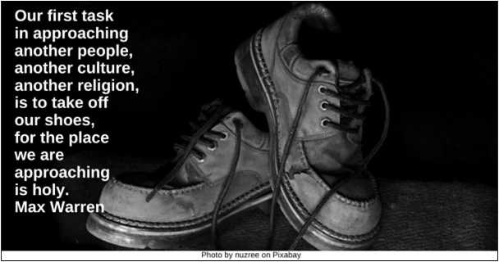

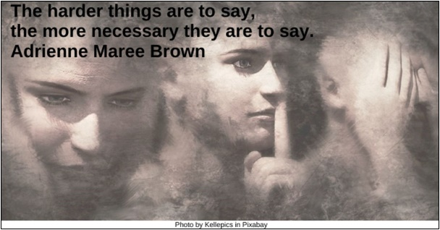

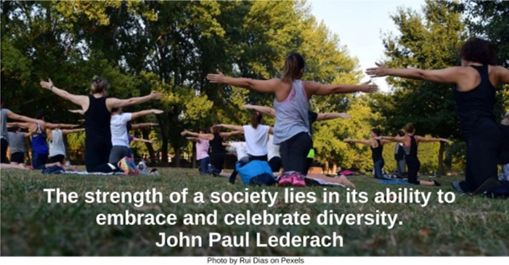

Teach Your Children HRJ
Thinking HRJ
Threads HRJ
Understanding HRJ

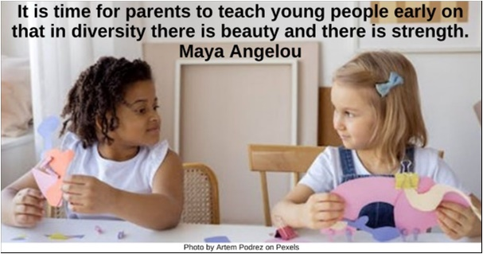

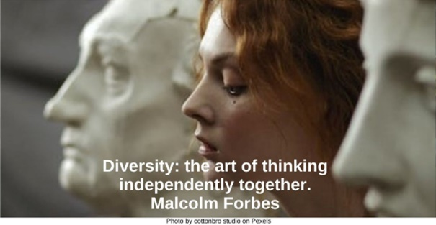

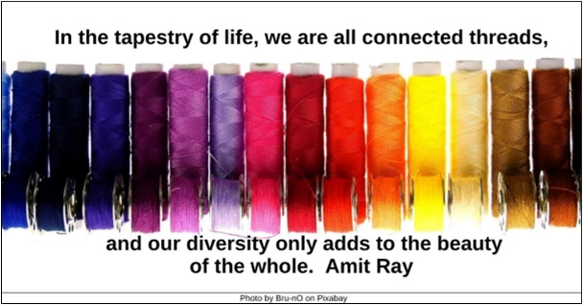

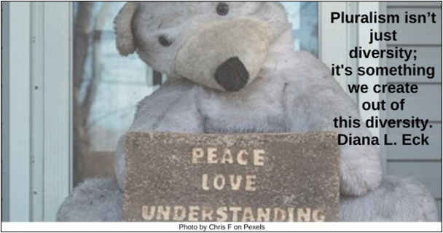

Unique Manifestations HRJ
Uniqueness HR
White Pawns HRJ

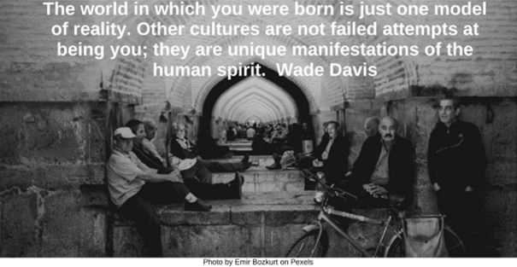

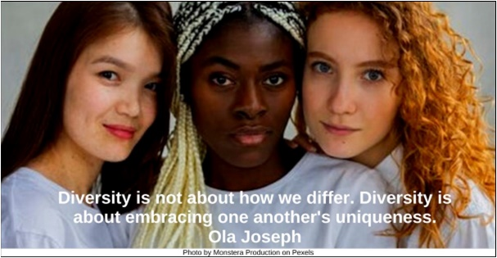

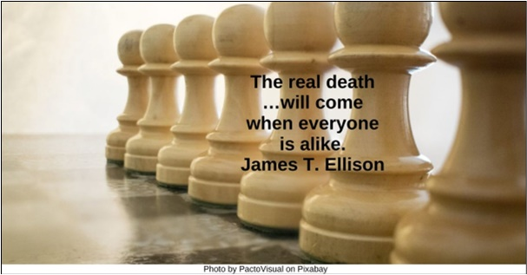

Text of Quotes
Authoritarianism HRJ
Low-intensity authoritarianism corrodes pluralism…. Padraig O'Malley

Beauty HRJ
In diversity, there is beauty and there is strength. Maya Angelou

Board Game HRJ
Pluralism is the idea that your way of life, your religion, your language, your way of being is …worthy of recognition and respect across the board. Raghuram Rajan

Celebration HRJ
The essence of pluralism is the acceptance of diversity, a celebration of interdependence and an openness to the richness of human experience. Diana L. Eck

Chorus HRJ
Pluralism is the call to appreciate the symphony of voices in our global chorus, each contributing to the melody of a harmonious coexistence. Eboo Patel

Civilization HRJ
Our ability to reach unity in diversity will be the beauty and the test of our civilization. Mahatma Gandhi

Complexity HRJ
A society that values pluralism is one that acknowledges the complexity of human existence…. Martha Nussbaum

Demographics HRJ
Pluralism is not simply a demographic fact but an achievement; it is not just a description of what is, but a prescription for what ought to be. Kwame Anthony Appiah

Dining Table HRJ
Humility is my table, respect is my garment, empathy is my food, and curiosity is my drink. Tariq Ramadan

Diversity of Approaches HRJ
A diversity of approaches is necessary if we are to solve the problems of the modern world. Dalai Lama

Education HRJ
The highest result of education is tolerance. Helen Keller

Empathy HRJ
The great gift of human beings is that we have the power of empathy, we can all sense a mysterious connection to each other. Meryl Streep

Encounter HRJ
Pluralism is a process of encounter and dialogue that respects differences and seeks understanding, not domination. Karen Armstrong

Flower Garden HRJ
In the garden of humanity, every flower has a right to bloom and contribute to the beauty of the whole. Reza Aslan

Gift HRJ
Pluralism is the idea that diversity is not a problem to be solved but a gift to be celebrated. Jonathan Sacks

Movement HRJ
Pluralism is a process and not a static state. It is a movement, not a condition. Abraham Joshua Heschel

Niagara Falls HRJ
A society being “pluralistic” is a reality (see Syria and Iraq). A society with pluralism “is an achievement” (see America [& Canada]). Thomas L. Friedman
Not Diversity Alone HRJ
Pluralism is not diversity alone, but the energetic engagement with diversity. Diana L. Eck

Other People HRJ
Pluralism is the idea that your way is not the only way, and that other people, with their differences, can also be right. Richard Rohr

Radiant HRJ
Pluralism is a radiant shimmer of the human imagination, a reflection of our human capacity to embrace diversity and live together in peace. Eboo Patel

Respect HRJ
The essence of pluralism is not that everyone agrees with one another. It is that they agree to disagree respectfully. Ravi Zacharias

Shoes HRJ
Our first task in approaching another people, another culture, another religion, is to take off our shoes, for the place we are approaching is holy. Max Warren

Speak Up HRJ
The harder things are to say, the more necessary they are to say. Adrienne Maree Brown

Strength HRJ
The strength of a society lies in its ability to embrace and celebrate diversity. John Paul Lederach

Teach Your Children HRJ
It is time for parents to teach young people early on that in diversity there is beauty and there is strength. Maya Angelou

Thinking HRJ
Diversity: the art of thinking independently together. Malcolm Forbes
Threads HRJ
In the tapestry of life, we are all connected threads, and our diversity only adds to the beauty of the whole. Amit Ray

Understanding HRJ
Pluralism isn’t just diversity; it's something we create out of this diversity. Diana L. Eck

Unique Manifestations HRJ
The world in which you were born is just one model of reality. Other cultures are not failed attempts at being you; they are unique manifestations of the human spirit. Wade Davis

Uniqueness HRJ
Diversity is not about how we differ. Diversity is about embracing one another's uniqueness. Ola Joseph

White Pawns HRJ
The real death …will come when everyone is alike. James T. Ellison

